

RFC 0113 - Device Management for Vehicle Device
Confidential, Draft
31 Pages

Abstract

Document Information

Table of Contents
0 Document Information 2
0.1 Table of Contents 2
0.2 Terminology and Document Conventions 5
0.3 Revision History 5
1 Introduction 5
2 Application Domain 5
2.1 Device Management domain for Vehicle Device 5
2.2 Entities 6
2.3 Standard References 7
3 Problem Description 8
4 Requirements 8
4.1 High Level Functional Requirements 8
4.1.2 Recording 9
4.2 Overall Systems Requirements 9
4.3 System Elements 9
4.3.1 Telematics Terminal 9
4.3.2 Telematics Server 10
4.3.3 Data Model 10
5 Technical Solution 11
5.1 Overview 11
5.2 Sequence Diagram 11
5.2.1 Software List Query 12
5.2.2 Telematics Device Configuration Management 13
5.2.3 Telematics Terminal Status Management 14
5.2.4 Vehicle Status Information Monitoring 15
5.2.5 Abnormal Vehicle Status Notification 16
5.2.6 Firmware Update 17
5.3 Class Diagram 18
6 Java API 18
6.1 Interface DangerStatusListener 18
6.1.1 action 19
6.2 Class TelematicsTerminal 19
6.2.1 getAvailableDiskSpace 20
6.2.2 setAvailableDiskSpace 20
6.2.3 getWholeMemory 20
6.2.4 setWholeMemory 21
6.2.5 getUsedMemory 21
6.2.6 setUsedMemory 21
6.2.7 addNewUSB 21
6.2.8 getUSBSate 21
6.2.9 getUSBList 21
6.2.10 getNumOfUSBPort 21
6.2.11 getNumOfUsedUSB 22
6.2.12 getNPortstate 22
6.2.13 getNPortList 22
6.2.14 getNumOfNPort 22
6.2.15 getNumOfUsedNPort 22
6.2.16 activateSWComponent 22
6.2.17 deactivateSWComponent 22
6.2.18 removeSWComponent 23
6.3 Class SWComponent 23
6.3.1 setName 24
6.3.2 getName 24
6.3.3 setCompID 24
6.3.4 getCompID 24
6.3.5 getVersion 24
6.3.6 setVersion 24
6.4 Class VehicleStatus 24
6.4.1 setPosition 25
6.4.2 setPosition 25
6.4.3 getAltitude 26
6.4.4 getLongitude 26
6.4.5 getLatitude 26
6.4.6 getSpeed 26
6.4.7 getDirection 26
6.5 Class VehAbnormalStatusQueue 26
6.5.1 ENGIN_TOO_HOT 27
6.5.2 SORTAGE_OF_FUEL 28
6.5.3 SORTAGE_OF_ENGINEOIL 28
6.5.4 BATTERY_LOW 28
6.5.5 MALFUNCTION_OF_BREAK 28
6.5.6 MALFUNCTION_OF_IGNITION 28
6.5.7 TOO_LOW_AIR_PRESSURE 28
6.5.8 DOOR_OPEN 28
6.5.9 EVENT_SIZE 28
6.5.10 VehAbnormalStatusQueue 28
6.5.11 getNextEvent 28
6.5.12 postEvent 29
6.6 Class NetworkPort 29
6.7 Class USBPort 29
7 Considered Alternatives 30
8 Security Considerations 30
9 Document Support 30
9.1 References 30
9.2 Author’s Address 30
9.3 Acronyms and Abbreviations 31
9.4 End of Document 31

Terminology and Document Conventions
The key words "MUST", "MUST NOT", "REQUIRED", "SHALL", "SHALL NOT", "SHOULD", "SHOULD NOT", "RECOMMENDED", "NOT RECOMMENDED", "MAY" and "OPTIONAL" in this document are to be interpreted as described in [1].
Source code is shown in this typeface.

Revision History
The last named individual in this history is currently responsible for this document.

Revision | Date | Comments
Initial  R1.1 | 2006.01.16 | Document Creation
R1.2 | 2006.03.04 | Chapter 7 Considered Alternatives are written by considering the comments issued in Sophia-Antipolis meeting(Jan. 19)

Introduction
This document describes the key entities and operations needed to manage a Telematics Terminal as part of OSGi platform.
This is an first draft of the device management domain model for vehicle device and API proposal for entities defined in the “RFP 69 – Device Management for Vehicle Device”

Application Domain

Device Management domain for Vehicle Device

The DM specification as defined by OSGi’s MEG forms the basis for the data model and on the operations on this model. This model extends it the DM specification for the vehicle device domain.

The MEG has already proposed the DM domain in RFP 58:

- Device configuration parameters setting/querying
- Application configuration parameters setting/querying
- Device characteristics monitoring
- Software provisioning
- Software repair

This RFC proposes to add vehicle specific data to the existing domain.
This vehicle specific data contains the status of other electronic devices in vehicle as well as vehicle diagnostics.
The AMI-C has defined standard APIs about various vehicle diagnostic statuses, and these APIs can be taken into account.

Entities

DMT
Device Management Tree, a logical entity representing all remotely manageable aspects of the device.
Telematics Terminal
A Telematics Terminal is a terminal device in a vehicle used for the telematics service.
It can be a mobile phone, PDA, etc.
Diagnostic
A Diagnostic is the status of a device connected to the car’s MOST network or CAN network.
Telematics Server
The Telematics Server is a server system which provides various telematics services.
TSP
Telematics Service Provider
User
The User is a driver or a fellow passenger in the vehicle who uses the telematics service.
Administrator
The Administrator is a telematics system administrator on the Telematics Server side.
Terminal Discovery
The Terminal Discovery is the method to push the Telematics Terminal to call or send data to the Telematics Server. E.g. SMS
Vehicle Status Information
Position, speed, moving direction of the vehicle and diagnosis signal of in-vehicle devices, etc
Replay Attack
The Replay Attack is a form of network attack in which a valid data transmission is repeated or delayed intentionally. This is carried out by the intruder who intercepts the data and retransmits it.

Standard References

AMI-C
AMI-C is a worldwide organization of motor vehicle manufacturers created to facilitate the development, promotion and standardization of automotive multimedia interfaces to motor vehicle communication networks.
Additional information can be found in http://www.ami-c.org

MOST
The MOST Cooperation is based on a partnership of carmakers, set makers, system architects and key component suppliers. Together they define and adopt a common multimedia network protocol and application object model.
Additional information can be found in http://www.mostcooperation.com

CAN
The CAN is a serial bus system, which was originally developed for automotive applications in the early 1980's and used as the in-vehicle network for the engine management, the body electronics like door and roof control, air conditioning, etc.
Additional information can be found in http://www.can-cia.org/

RFC 85 Device Management
The RFC 85 defines simple and consistent API providing access method to the device management information.
Additional information can be found in http://membercvs.osgi.org/rfcs/rfc0085.

RFC 87 Device Management Tree Structure
The RFC 87 specifies how information related to configuration, logging, monitoring, deployment, applications and policy is mapped to the Device Management Tree.
Additional information can be found in http://membercvs.osgi.org/rfcs/rfc0087.

Problem Description
Device management for vehicle device is required to provide verified and seamless telematics service for User and to manage problems promptly and appropriately.

Although MEG in OSGi defines the device management for mobile device, more additional functions are needed for the special feature of vehicle device:

- It is hard to change the configuration and environment of vehicle device after initial installation. Therefore the remote managing functions should be provided.
- The devices which are connected to the terminal should be managed through the standardized interface.
- The following vehicle status should be collected and monitored for the drivers’ safety and convenience.
- Current moving speed
- Current moving direction
- Current position
- Air pressure of tires
- Door lock status
- Internal temperature of engine
- Other diagnosis signal of vehicle devices

Requirements

High Level Functional Requirements

4.1.1 Security
  - An Authentication mechanism is needed.
  - The authentication procedure must be strong enough to ensure that is not possible for a third party to masquerade as a Telematics Server by spoofing its identity.
  - The Telematics Terminal and Telematics Server must be capable of detecting replay attacks.
  - If User confirmation is indicated by the Telematics Server, the Terminal will prompt for User confirmation before accepting the changes.
  - The non-repudiation of the session must be ensured.
  - For the driver’s privacy, the position information of the vehicle should be encrypted.

Recording
  - The Telematics Terminal Management System shall provide sufficient information so that queries from the Telematics Server, reports from Terminals, data downloads, and acknowledgements may be billed and tracked accordingly.
  - A session must be uniquely identified.
  - If transactions are logged, the server must log transactions with success indicator.

4.1.3 Administration and Configuration
  - The Telematics Terminal Management System shall provide a standardized mechanism for publishing session/message transactions such as confirmation requests and results.
  - Confirmation request messages shall be uniquely identified and contain at least the subscriber id, data or data summary, and date/time.
  - Confirmation result messages shall be uniquely identified and correlated to the request.
4.1.4 Usability
  - If User confirmation is indicated by the Telematics Server, the Terminal shall ask for User confirmation before incorporation of configuration data (transferred by Telematics Server).
  - The Terminal may have a dedicated connection for the server.
  - For safety reasons the user should only be prompted if his input is required.
  - User may be informed that a process is over.
  - The User shall be asked for confirmation to proceed before any software is updated.
  - The User shall be informed that the update/upgrade has been completed.

Overall Systems Requirements

- The Telematics Terminal Management infrastructure may be based on a distributed architecture, wherein functional elements of the system (e.g., TSP server) may consist of one or more coordinated, but physically separate entities.
- Terminal Discovery by the Telematics Server must be clearly defined (e.g. SMS).

System Elements

Telematics Terminal
- It must be possible for the User to view, change and store terminal environment parameters.
- It must be possible for the User to view, change and store application specific configuration parameters.
- It should be possible for the User to manage the list of S/W packages.
- An authorized User must be able to install, update and uninstall system software (including firmware).
- It must be possible for the User to check the Telematics Terminal’s status.
- It must be possible for the User to check the in-vehicle device’s status.
- Re-setting configuration parameters and/or policies to their factory-defined state may be supported.
- The Telematics Terminal must be able to notify the Telematics Terminal Management server that it has accepted and successfully saved the downloaded data.

Telematics Server
- The Telematics Server shall be capable of discovering the presence of the active Telematics Terminals
- The Telematics Server shall be capable of querying Terminals for information about their configuration.
- The message from the Terminal acknowledging a terminal management operation shall contain an indication of success/failure of the operation.
- The Telematics Server shall be capable of sending a request for User confirmation to the Terminal, and accepting the response from the Terminal.
- The Telematics Server shall be able to establish a secure data connection to the Terminal.
- The Telematics Server should support at least one wireless bidirectional data bearer.
- The Telematics Server must be able to detect when a Terminal needs data update.

Data Model

- Installed S/W Package List
- Name
- Version information
- Dependency, etc.
- Network Configuration
- Phone number
- Default TSP server URL, etc.
- General Device Environment Parameters
- Device ID
- Device model
- Version information, etc.

- Application Specific Configuration
- TBD
- Information about Telematics Terminal status
- Device ID
- Firmware version
- Available disk space
- Available memory, etc.
- Information about vehicle status
- Position
- Speed
- Temperature
- Diagnostics signal, etc.

Technical Solution

Overview
The architecture of Device Management for Vehicle Device is based on DMT model in OMA DM and “RFC 85 – Device Management”.
So the DmtAdmin, DmtSession, Dmt interfaces and the DmtAcl class can be used and expanded for the vehicle device.

Sequence Diagram

Software List Query
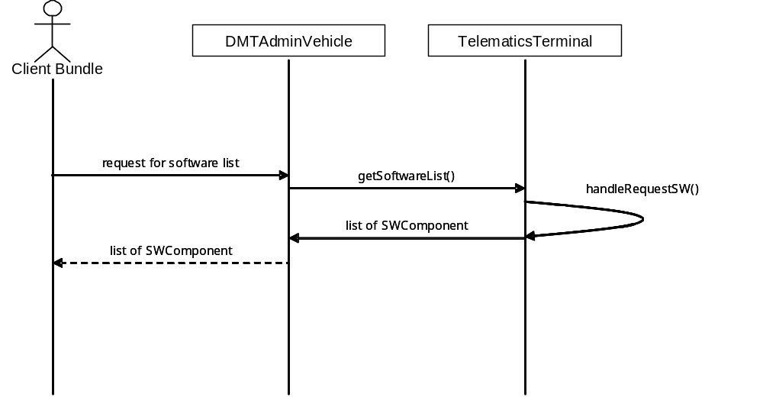

Figure1. Software List Query

- The DMTAdminVehicle interface is inherited from DMTAdmin(RFC 58)
- The SWComponent class may contain id, name, version, etc.

The client bundle requests to DmtAdminVehicle for the software list
The DmtAdminVehicle responds with the software (SWComponent instance) list.

Telematics Device Configuration Management

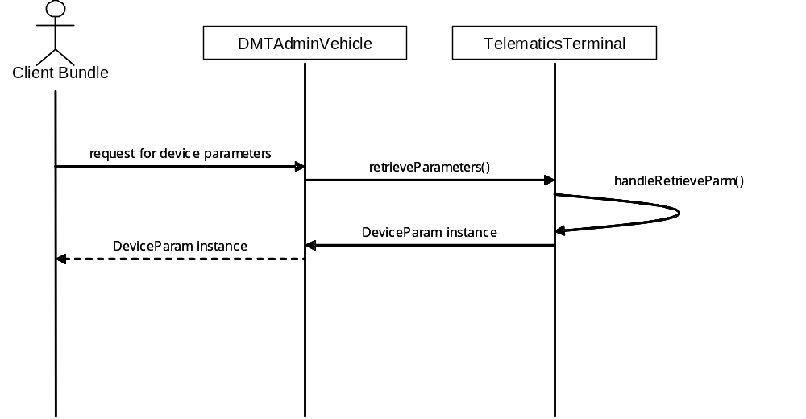

Figure2. Telematics Device Configuration Management

- The DMTAdminVehicle interface is inherited from DMTAdmin(RFC 58)
- The DeviceParam class may contain id, model no, version, manufacturer, etc.

The client bundle requests to DmtAdminVehicle for the configuration parameters.
The DmtAdminVehicle responds with the configuration parameters (DeveceParam instance).

Telematics Terminal Status Management

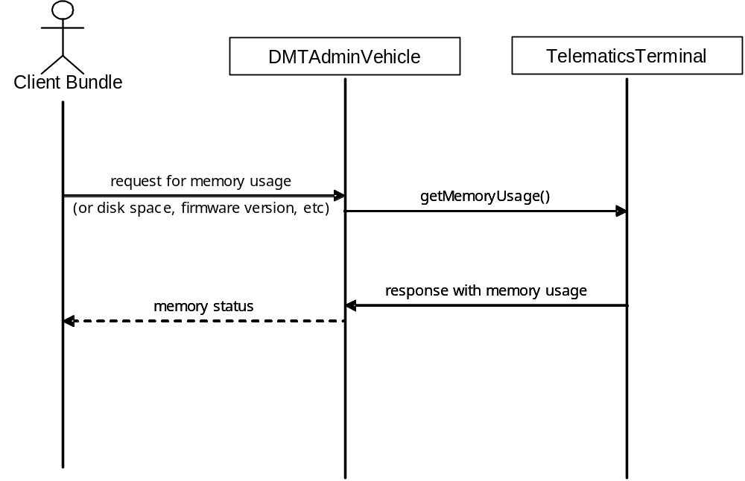

Figure3. Telematics Terminal Status Management

- The DMTAdminVehicle interface is inherited from DMTAdmin(RFC 58)

The client bundle requests to DMTAdminVehicle for the Terminal status value (e.g. memory usage).
The DMTAdminVehicle responds with the memory usage.

Vehicle Status Information Monitoring
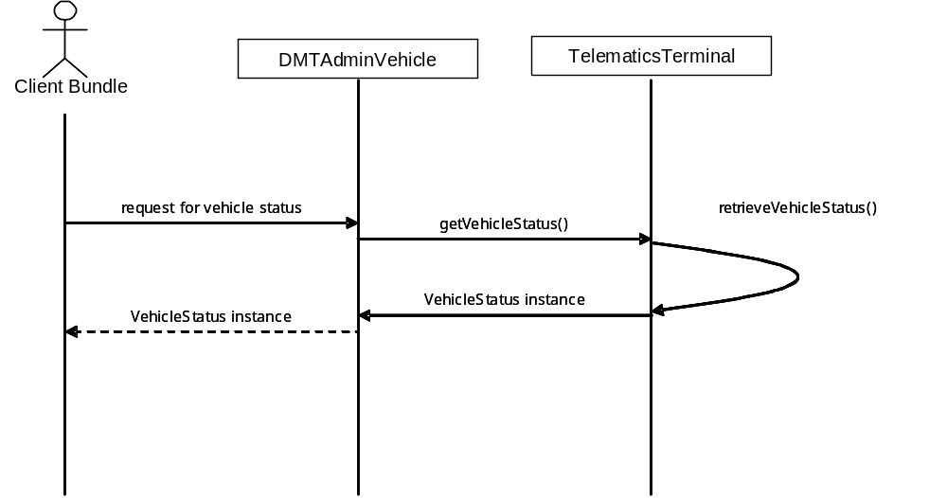

Figure4. Vehicle Status Information Monitoring

- The DMTAdminVehicle interface is inherited from DMTAdmin(RFC 58)
- The VehicleStatus class may contain speed, direction, position, etc.

The client bundle requests to DMTAdminVehicle for the vehicle status information.
The TelematicsTerminal class collects the vehicle status information.
The DMTAdminVehicle responds with the vehicle status information (VehicleStatus instance).

Abnormal Vehicle Status Notification
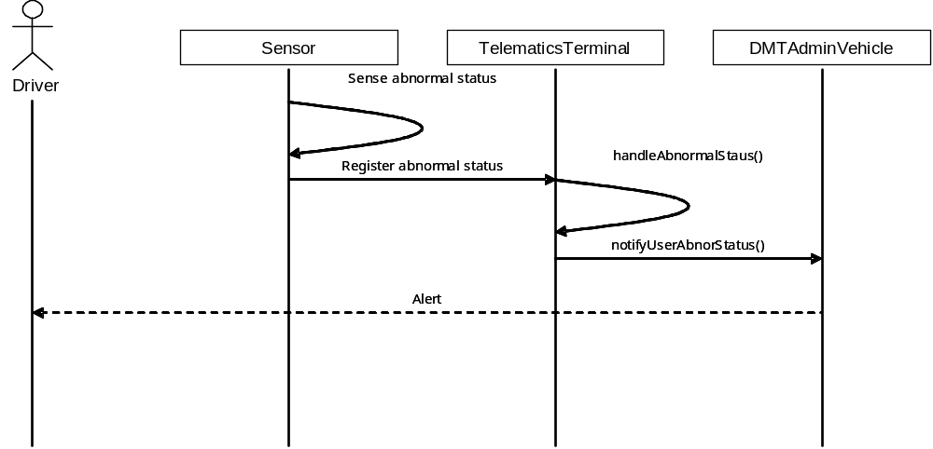

Figure5. Abnormal Vehicle Status Notification

- The DMTAdminVehicle interface is inherited from DMTAdmin(RFC 58)

The sensor of the vehicle senses the abnormal vehicle status and put the abnormal status in the queue.
The Telematics Terminal handles the abnormal status queue and sends the event to the DmtAdminVehicle.
The DmtAdminVehicle alert the abnormal status to the user.

Firmware Update
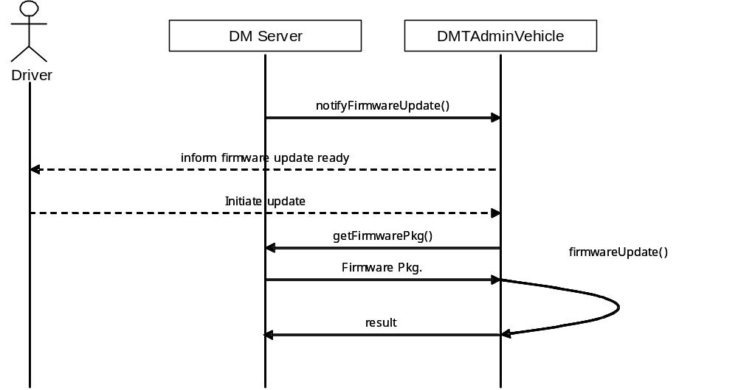

Figure6. Firmware Update

- The DMTAdminVehicle interface is inherited from DMTAdmin(RFC 58)
- The mechanism of the Firmware Update in the MEG environment can be used.

The DM Server notify to the DmtAdminVehicle for the firmware update.
The DmtAdminVehicle inform user the firmware update and user confirm.
The DmtAdminVehicle requests to the DM Server for the update package, and download the package from the DM Server.

Class Diagram

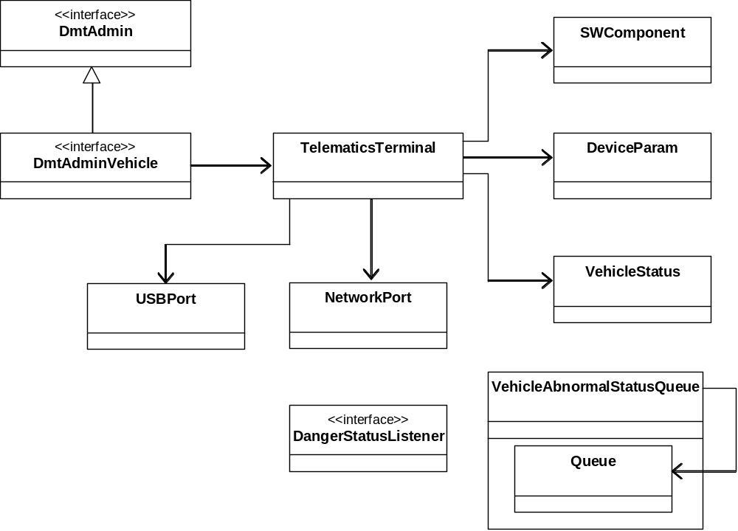

Figure7. Class Diagram

Java API

Interface DangerStatusListener

public interface DangerStatusListener
Defines an object which listens for DangerStatusEvents.

Method Summary
void | action(java.lang.String desc,int level)  Invoked when the target of the listener get into abnormal or dangerous status.

Method Detail

action
public void action(java.lang.String desc,
int level)
Invoked when the target of the listener get into abnormal or dangerous status.
Parameters:
desc - description of the status
level - level of the danger

Class TelematicsTerminal
java.lang.Object
vehicle.dm.TelematicsTerminal

public class TelematicsTerminal
extends java.lang.Object
Monitors the current status of the Telematics Terminal. The User or the Administrator wants to inspect the current status of the Telematics Terminal. A request is sent to the device management system with the name of the status information to be queried. Then the device management system responds the value of the status information (e.g. available disk space, memory usage, running applications, etc.).

Method Summary
void | addNewUSB(int portNum, boolean state)  Adds a USB information to the USB list.
int | getAvailableDiskSpace()  Gets the available disk space of the Terminal.
java.util.Vector | getNPortList()  Gets the list of the network list.
boolean | getNPortstate(int portNum)  Gets the state of the network port
int | getNumOfNPort()  Gets the number of network ports.
int | getNumOfUSBPort()  Gets the number of USB ports.
int | getNumOfUsedNPort()  Gets the number of network ports which is being used.
int | getNumOfUsedUSB()  Gets the number of USB ports which is being used.
java.util.Vector | getUSBList()  Gets the list of the USB list.
boolean | getUSBSate(int portNum)  Gets the state of the USB port
int | getUsedMemory()  Gets the used memory.
int | getWholeMemory()  Returns the whole size of the memory.
void | removeSWComponent(SWComponent swComp)  Removes a SW component in the list.
void | setAvailableDiskSpace(int diskSize)  Sets the available disk space of the Terminal.
void | setUsedMemory(int memSize)  Sets the used memory.
void | setWholeMemory(int memSize)  Sets the whole size of the memory.
void | deActivateSWComp(SWComponent swComp)  Deactivates an instance of SWComponent which is in activation.
void | activateSWComp(SWComponent swComp)  Activates an instance of SWComponet which is in deactivation.

Methods inherited from class java.lang.Object
equals, getClass, hashCode, notify, notifyAll, toString, wait, wait, wait

Method Detail

getAvailableDiskSpace
public int getAvailableDiskSpace()
Gets the available disk space of the Terminal.
Returns:
the available disk space

setAvailableDiskSpace
public void setAvailableDiskSpace(int diskSize)
Sets the available disk space of the Terminal.
Parameters:
diskSize - the available disk space

getWholeMemory
public int getWholeMemory()
Returns the whole size of the memory.
Returns:
the whole size of the memory

setWholeMemory
public void setWholeMemory(int memSize)
Sets the whole size of the memory.
Parameters:
memSize - the whole memory of the device

getUsedMemory
public int getUsedMemory()
Gets the used memory.
Returns:
the used memory

setUsedMemory
public void setUsedMemory(int memSize)
Sets the used memory.
Parameters:
memSize - the used memory

addNewUSB
public void addNewUSB(int portNum,
boolean state)
Adds a USB information to the USB list.
Parameters:
portNum - the USB port number
state - state of the port

getUSBSate
public boolean getUSBSate(int portNum)
Gets the state of the USB port
Parameters:
portNum - number of the port
Returns:
true, if the port is being used.

getUSBList
public java.util.Vector getUSBList()
Gets the list of the USB list.
Returns:
the USB list

getNumOfUSBPort
public int getNumOfUSBPort()
Gets the number of USB ports.
Returns:
the number of USB ports

getNumOfUsedUSB
public int getNumOfUsedUSB()
Gets the number of USB ports which is being used.
Returns:
the number of USB ports

getNPortstate
public boolean getNPortstate(int portNum)
Gets the state of the network port
Parameters:
portNum - number of the port
Returns:
true, if the port is being used.

getNPortList
public java.util.Vector getNPortList()
Gets the list of the network list.
Returns:
the network list

getNumOfNPort
public int getNumOfNPort()
Gets the number of network ports.
Returns:
the number of network ports

getNumOfUsedNPort
public int getNumOfUsedNPort()
Gets the number of network ports which is being used.
Returns:
the number of network ports

activateSWComponent
public void activateSWComponent(SWComponent swComp)
Activates a SWComponent which is in deactivation.
Parameters:
swComp - an instance of SWComponent

deactivateSWComponent
public void deactivateSWComponent(SWComponent swComp)
Deactivates a SWComponent which is in activation.
Parameters:
swComp - an instance of SWComponent

removeSWComponent
public void removeSWComponent(SWComponent swComp)
Removes an application in the list.
Parameters:
swComp - an instance of SWComponent

Class SWComponent
java.lang.Object
vehicle.dm.SWComponent
All Implemented Interfaces:
java.io.Serializable

public class SWComponent
extends java.lang.Object
implements java.io.Serializable
Keeps the information matching to an SW component on the telematics device. An instance of this class can be compared to an SW component directly. Information(version, size, name) can be managed by an instance of this class.
See Also:
Serialized Form

Method Summary
int | getCompID()  Gets the SW component.
java.lang.String | getName()  Gets the name of the SW component
java.lang.String | getVersion()  Gets version of the SW component.
void | setCompID(int aCompID)  Sets SW component ID of the SW component.
void | setName(java.lang.String aName)  Sets name of the SW component
void | setVersion(java.lang.String aVersion)  Sets version of the SW component with the given version.

Methods inherited from class java.lang.Object
equals, getClass, hashCode, notify, notifyAll, toString, wait, wait, wait

Method Detail

setName
public void setName(java.lang.String aName)
Sets name of the SW component
Parameters:
aName - name of an SW component

getName
public java.lang.String getName()
Gets the name of the SW component
Returns:
name of the SW component represented by this object.

setCompID
public void setCompID(int aCompID)
Sets SW component ID of the SW component.

getCompID
public int getCompID()
Gets the SW component.
Returns:
SW component

getVersion
public java.lang.String getVersion()
Gets version of the SW component.
Returns:
the version of the SW component

setVersion
public void setVersion(java.lang.String aVersion)
Sets version of the SW component with the given version.
Parameters:
aVersion - a version of the SW component

Class VehicleStatus
java.lang.Object
vehicle.dm.VehicleStatus

public class VehicleStatus
extends java.lang.Object
Keeps the current status of this vehicle. This class provides information of a vehicle. For example the status of the vehicle (e.g. location, speed, moving direction, etc.) This kind of information can be transferred to the device management system. The device management system sends the response of the status information which is collected through the internal network in vehicle (e.g. CAN and MOST).

Method Summary
Measurement | getAltitude()  Returns the altitude of this vehicle in meters.
Measurement | getDirection()  Returns the track of this position in radians as a compass heading.
Measurement | getLatitude()  Returns the latitude of this vehicle in radians.
Measurement | getLongitude()  Returns the longitude of this vehicle in radians.
Measurement | getSpeed()  Returns the ground speed of this vehicle in meters per second.
void | setPosition(Measurement lat, Measurement lon, Measurement alt, Measurement speed, Measurement track)  Sets the vecPosition object with the given values.
void | setPosition(Position aPos)  Set this vehicle's position whth the given value(Postion)

Methods inherited from class java.lang.Object
equals, getClass, hashCode, notify, notifyAll, toString, wait, wait, wait

Method Detail

setPosition
public void setPosition(Position aPos)
Set this vehicle's position whth the given value(Postion)
Parameters:
aPos - aPos a Postion object specifying a geographic location.

setPosition
public void setPosition(Measurement lat,
Measurement lon,
Measurement alt,
Measurement speed,
Measurement track)
Sets the vecPosition object with the given values.
Parameters:
lat - a Measurement object specifying the latitude in radians, or null
lon - a Measurement object specifying the longitude in radians, or null
alt - a Measurement object specifying the altitude in meters, or null
speed - a Measurement object specifying the speed in meters per second, or null
track - a Measurement object specifying the track in radians, or null
Returns:
void

getAltitude
public Measurement getAltitude()
Returns the altitude of this vehicle in meters.
Returns:
a Measurement object in Unit.m representing the altitude in meters above the ellipsoid null if the altitude is not known.

getLongitude
public Measurement getLongitude()
Returns the longitude of this vehicle in radians.
Returns:
a Measurement object in Unit.rad representing the longitude, or null if the longitude is not known.

getLatitude
public Measurement getLatitude()
Returns the latitude of this vehicle in radians.
Returns:
a Measurement object in Unit.rad representing the latitude, or null if the latitude is not known..

getSpeed
public Measurement getSpeed()
Returns the ground speed of this vehicle in meters per second.
Returns:
a Measurement object in Unit.m_s representing the speed, or null if the speed is not known..

getDirection
public Measurement getDirection()
Returns the track of this position in radians as a compass heading. The track is the extrapolation of previous previously measured positions to a future position.
Returns:
a Measurement object in Unit.rad representing the track, or null if the track is not known.

Class VehAbnormalStatusQueue
java.lang.Object
vehicle.dm.VehAbnormalStatusQueue

public class VehAbnormalStatusQueue
extends java.lang.Object
This is a queue class storing events related to abnormal or dangerous status of a vehicle. The vehicle's sensor can perceive abnormal or dangerous status and call postEvent() method to store the event in this queue. DM system will read these events from this event queue.

Field Summary
static int | BATTERY_LOW  the battery needs to be recharged
static int | DOOR_OPEN  door is open duing driving
static int | ENGIN_TOO_HOT  the engine temperature is too high
static int | EVENT_SIZE
static int | MALFUNCTION_OF_BREAK  the break doesn't work well
static int | MALFUNCTION_OF_IGNITION  problems on the ignition system
static int | SORTAGE_OF_ENGINEOIL  sotrage of engine oil
static int | SORTAGE_OF_FUEL  sortage of fuel
static int | TOO_LOW_AIR_PRESSURE  too low air pressure of a tire

Constructor Summary
VehAbnormalStatusQueue()
default constructor

Method Summary
void | getNextEvent(int[] event)  Gets a new event.
boolean | postEvent(int[] event)  Stores a new event in this event queue.

Methods inherited from class java.lang.Object
equals, getClass, hashCode, notify, notifyAll, toString, wait, wait, wait

Field Detail

ENGIN_TOO_HOT
public static int ENGIN_TOO_HOT
the engine temperature is too high

SORTAGE_OF_FUEL
public static int SORTAGE_OF_FUEL
sortage of fuel

SORTAGE_OF_ENGINEOIL
public static int SORTAGE_OF_ENGINEOIL
sotrage of engine oil

BATTERY_LOW
public static int BATTERY_LOW
the battery needs to be recharged

MALFUNCTION_OF_BREAK
public static int MALFUNCTION_OF_BREAK
the break doesn't work well

MALFUNCTION_OF_IGNITION
public static int MALFUNCTION_OF_IGNITION
problems on the ignition system

TOO_LOW_AIR_PRESSURE
public static int TOO_LOW_AIR_PRESSURE
too low air pressure of a tire

DOOR_OPEN
public static int DOOR_OPEN
door is open duing driving

EVENT_SIZE
public static int EVENT_SIZE
Constructor Detail

VehAbnormalStatusQueue
public VehAbnormalStatusQueue()
default constructor
Method Detail

getNextEvent
public void getNextEvent(int[] event)
Gets a new event. A new event copied to interger array. The first element of the array keeps the event type. The rest information being stored at the next elements of the array along with the event type. Event array size shoud be larger than EVNET_SIZE: if not, throws ArrayIndexOutOfBoundsException This method will be called a thread processing events. if not, throws IllegalThreadStateeException.
Parameters:
event - Where events are stored
Throws:
java.lang.ArrayIndexOutOfBoundsException - When event array size is smaller than'EVENT_SIZE'
java.lang.IllegalThreadStateException - When this method is called by a thread which is not releted to event processing

postEvent
public boolean postEvent(int[] event)
Stores a new event in this event queue. returns false, if event queue is full returns true, if the event is stored in the event queue.
Parameters:
event - a event being stored
Returns:
true - if the event was stored false - if it fails
Throws:
java.lang.ArrayIndexOutOfBoundsException - When event array size is smaller than'EVENT_SIZE'.
java.lang.NullPointerException - If the event is null.

Class NetworkPort
java.lang.Object
vehicle.dm.NetworkPort

public class NetworkPort
extends java.lang.Object
An instance of the class represents a network port in a telematics device. It keeps general information of network port(port number, usage)

Methods inherited from class java.lang.Object
equals, getClass, hashCode, notify, notifyAll, toString, wait, wait, wait

Class USBPort
java.lang.Object
vehicle.dm.USBPort

public class USBPort
extends java.lang.Object
An instance of the class represents a USB port in a telematics device. It keeps general information of USB port(port number, usage)

Methods inherited from class java.lang.Object
equals, getClass, hashCode, notify, notifyAll, toString, wait, wait, wait

Considered Alternatives
This RFC has some overlap with other RFCs as follows. Therefore this RFC should be revised drastically suggesting new points which are more vehicle-specific and escape the overlaps.

RFC113 subparts | Other RFCs
1.1 Software List Query | OSGI Framework includes same methods as follows  org.osgi.framework.getRegisteredServices() (R4 p129)  org.osgi.framework.getServicesInUse() (R4 p130)
1.2 Telematics Device Configuration Management | RFC9 – Preferences API  PreferenceService.getSystemPreferences()
1.3 Telematics Terminal Status Management | SWComponent is similar to Bundle Object
1.4 Vehicle Status Information Monitoring | Overlap with RFC 34 – Vehicle API  (VehicleService, SatusListener, Status, StatusDescriptor)
1.5 Abnormal Vehicle Status Notification | RFC 34
1.6 Firmware Update | Bundle can be updated by R4 Core Spec, Bundle Object  INSTALLED/RESOLVED/STARTING/ACTIVE/STOPPING/UNINSTALLED

Security Considerations
Description of all known vulnerabilities this may either introduce or address as well as scenarios of how the weaknesses could be circumvented.

Document Support

References
- Bradner, S., Key words for use in RFCs to Indicate Requirement Levels, RFC2119, March 1997.
- Software Requirements & Specifications. Michael Jackson. ISBN 0-201-87712-0
- RFP 37 - Navigation Domain Model, OSGi Alliance
- RFP 42 - Diagnostics, OSGi Alliance
- RFP 58 - MEG Device Management, OSGi Alliance
- AMI-C Release 2 architectural overview, AMI-C
- AMI-C use cases, AMI-C
- Device Management Requirements, OMA

Author’s Address

Name | Kyong-Ho Kim
Company | ETRI, TelematicsUSN Research Division
Address | 161 Gajung-dong, Yusong-gu, Daejon, Korea
Voice | +82-42-869-1634
e-mail | kkh@etri.re.kr

Acronyms and Abbreviations

End of Document

